**Smart Motorcycle**

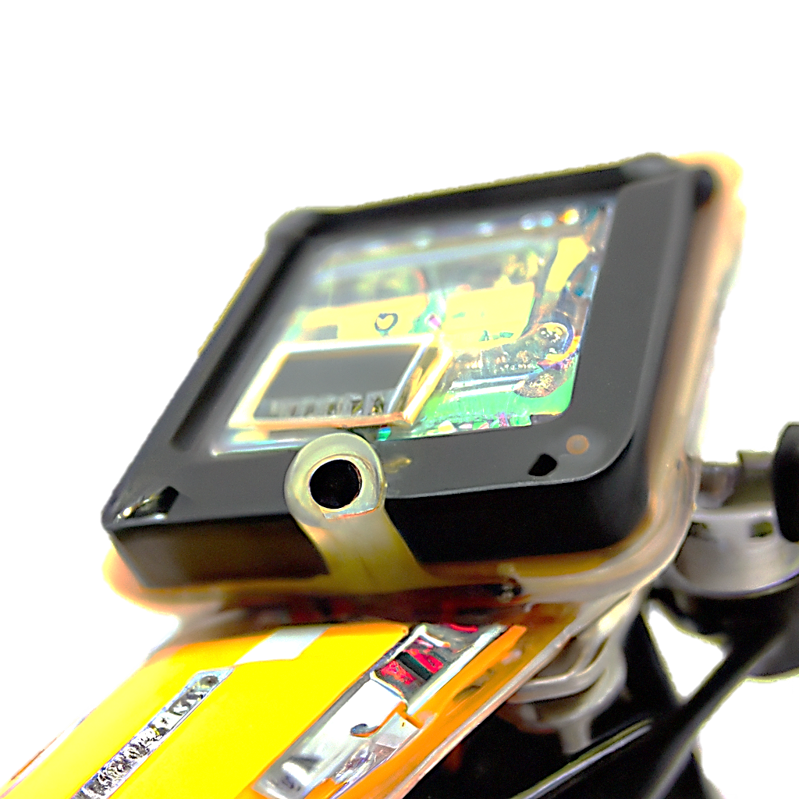

[**https://github.com/ahmedrsamak**](https://github.com/ahmedrsamak)

**Egypt, Cairo**

**+201146332489**

[**ahmedrsamak@gmail.com**](mailto:ahmedrsamak@gmail.com?subject=Smart%20Motorcycle)

Contents

Abstract 3

Fuel Level sensor 4

# Abstract

This project aims to create a smart scooter monitoring system that will monitor all sensors such as fuel level, motor temperature, and accelerometer, and control the ignition and lighting. An Android application will be programmed using Flutter to display data and control the scooter remotely, and microcontrollers will be used to process the data collected by the sensors.

The smart scooter monitoring system will consist of several sensors that will collect data on the scooter's performance and status. The fuel level sensor will monitor the amount of fuel in the tank and provide real-time updates to the rider. The motor temperature sensor will monitor the temperature of the motor and provide alerts when it reaches a dangerous level. The accelerometer sensor will monitor the acceleration and deceleration of the scooter, which can be used to provide insights on the rider's driving behavior.

The data collected by the sensors will be processed by microcontrollers, which will be responsible for collecting, processing, and transmitting the data to the Android application. The microcontrollers will also control the ignition and lighting of the scooter based on the commands received from the Android application.

The Android application will provide a user-friendly interface to display the real-time data collected by the sensors on the scooter. The application will enable the rider to monitor the fuel level, motor temperature, and acceleration and deceleration of the scooter remotely. The ignition and lighting control systems will also be integrated into the application, allowing the rider to control the start and stop of the motor, ignition, and lighting of the scooter remotely.

The application will be programmed using Flutter, an open-source framework for developing mobile applications. The framework will enable the development of a responsive and intuitive user interface that will work seamlessly across multiple platforms. Flutter also provides a rich set of pre-built widgets that will be used to develop the application's user interface.

In conclusion, this project aims to develop a smart scooter monitoring system that will monitor all sensors on the scooter and control the ignition and lighting remotely. An Android application using Flutter will be programmed to display the real-time data collected by the sensors and control the scooter remotely. Microcontrollers will be used to process the data collected by the sensors and control the ignition and lighting of the scooter. The integration of these systems will provide a comprehensive and intelligent monitoring system for scooter riders, enabling them to make informed decisions and avoid potential safety hazards.

# Fuel Level sensor

A fuel level sensor is a device that measures the amount of fuel in a tank and provides feedback to a vehicle's fuel gauge or monitoring system. It is a crucial component in accurately determining how much fuel is available for use in a vehicle or other equipment. The sensor typically uses a float that is suspended in the fuel, which moves up or down based on the fuel level. The movement of the float is then converted into an electrical signal that is sent to the fuel gauge or monitoring system. Fuel level sensors are commonly used in cars, trucks, boats, and other vehicles, as well as in industrial applications such as fuel storage tanks. They play a vital role in ensuring that drivers or operators have an accurate understanding of the amount of fuel available, which can help prevent issues such as running out of fuel or overfilling the tank.